README FIRST

For part 1 :

there are three search box, each indicates KMP, brute force and Boyer Moore (challenge)

look like this:

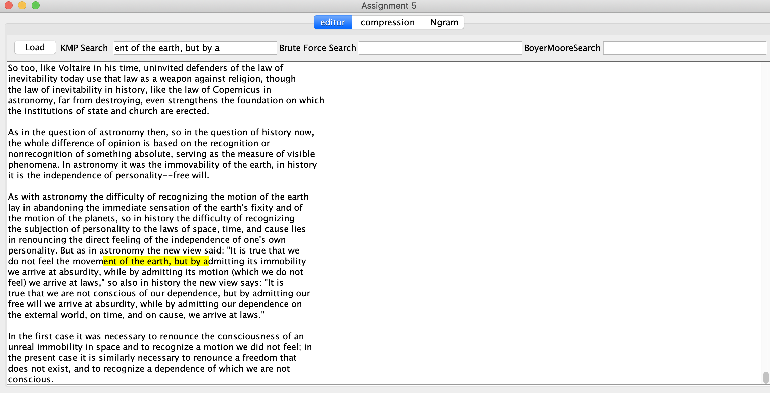

for part 2 and part 3 :

select a input file and a random out put

the output for huffman should look like:

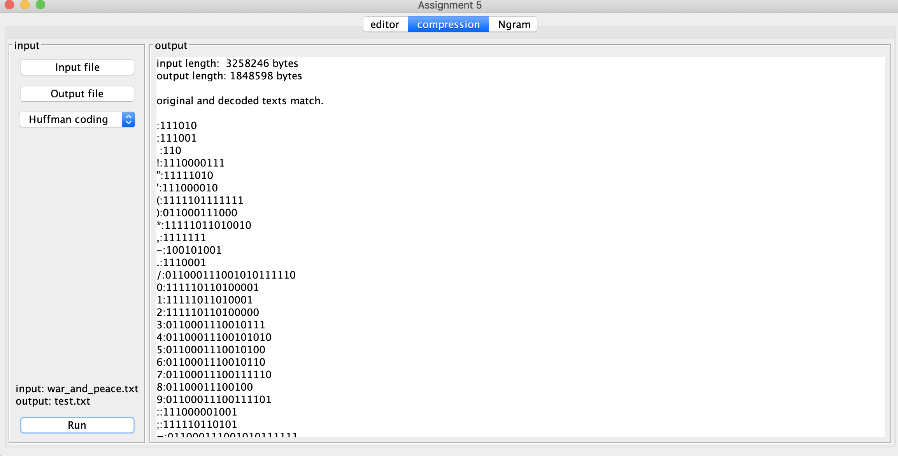

the output for Lempel Ziv should look like :

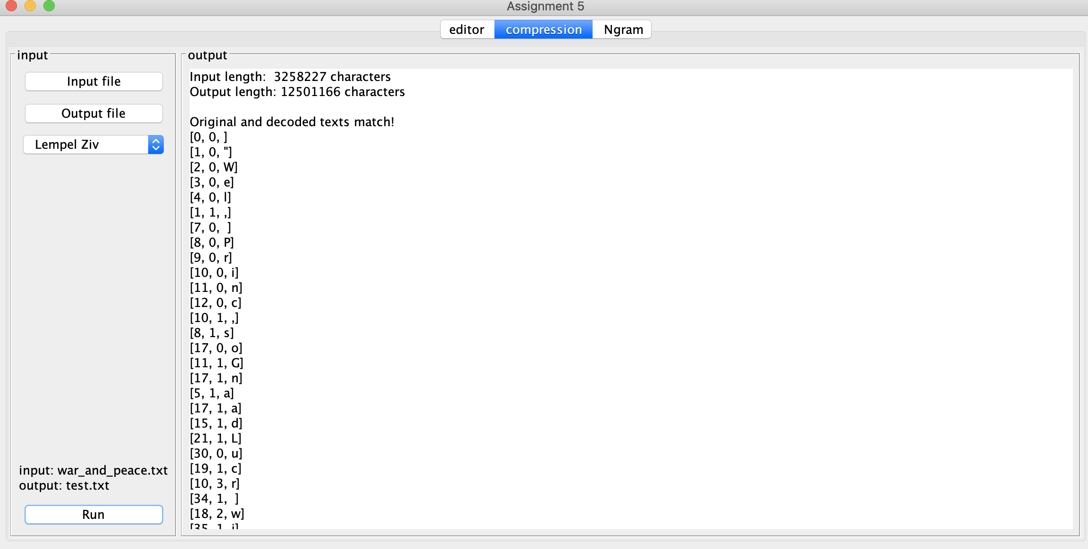

for part 4 :

click load ngram to load a file and form a ngram table

there are two search box :

the first one , you can input a n number between 0-5, and the ngram table of specific number will show

if I select 5, this is the output:

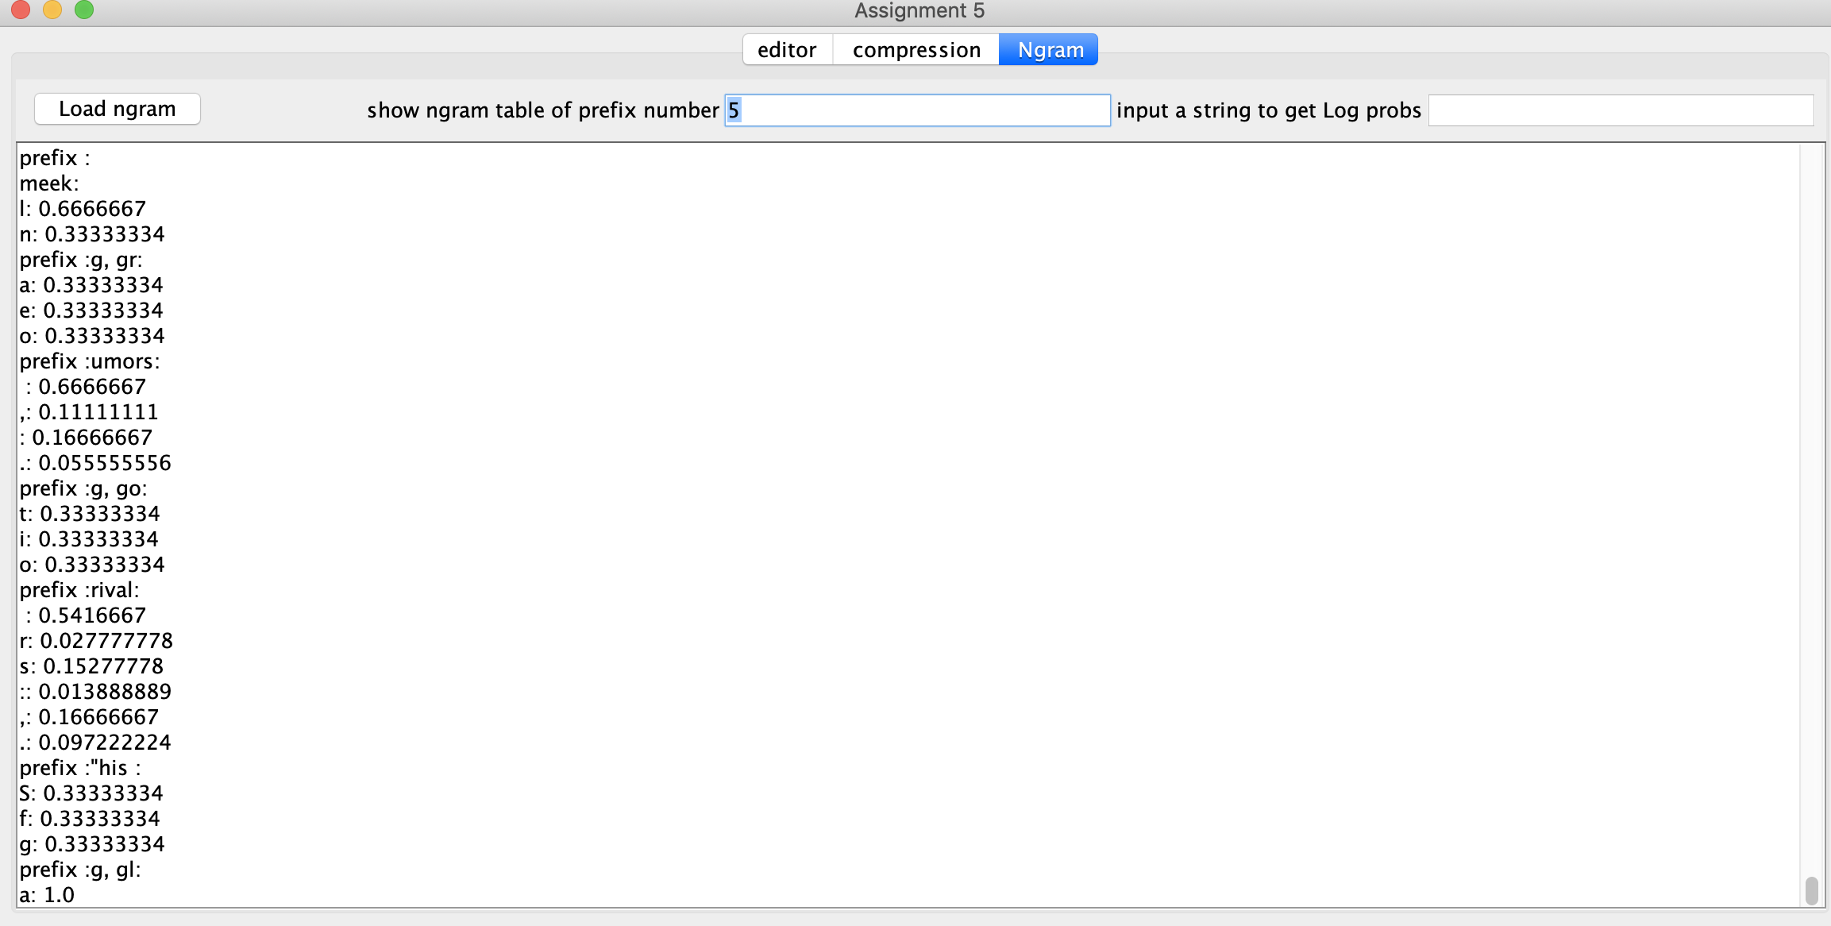

the second search box is to check the log probs of a input string

if we input a string, the output should be:

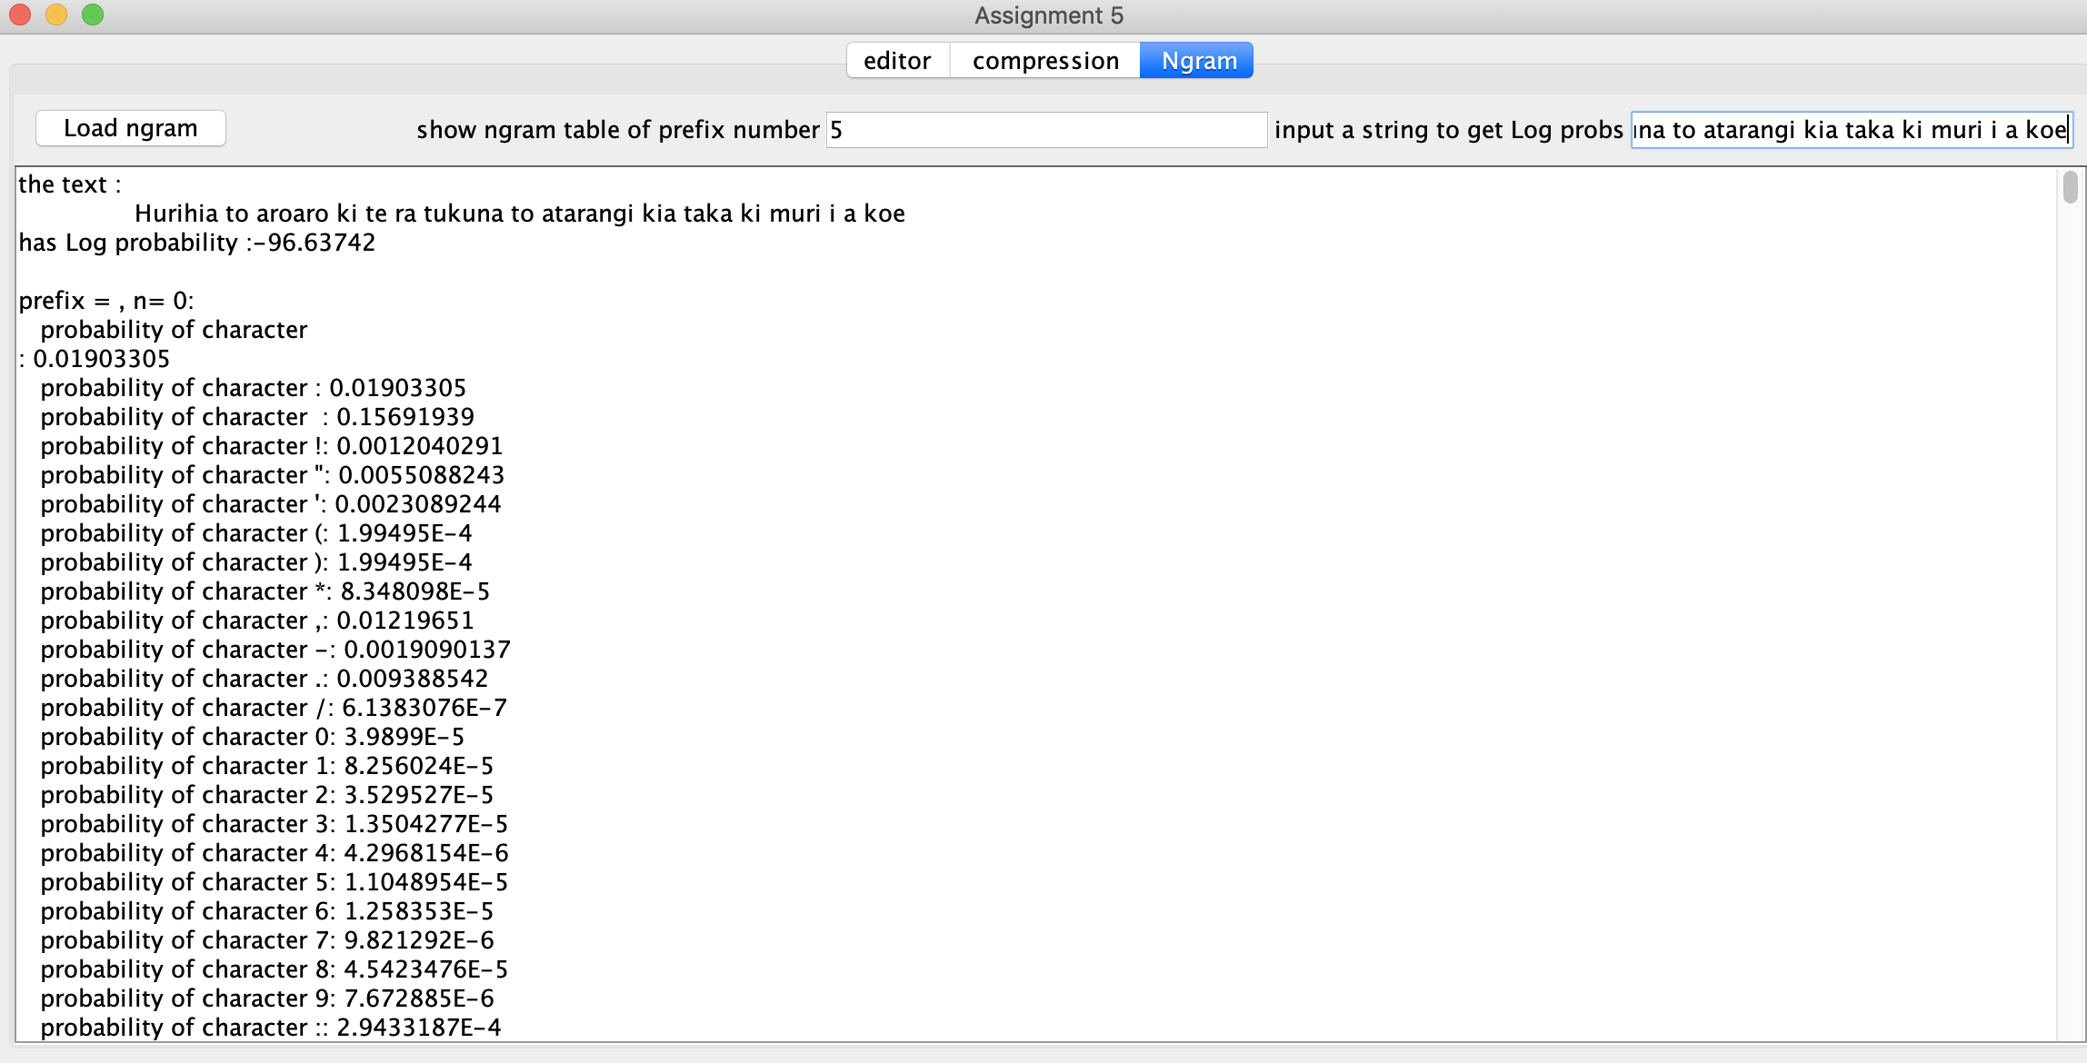

for part 5 :

I did Boyer Moore which already mentioned in part 1.